**P4 – Implement a working object oriented application to meet defined requirements**

**Introduction**

In this report, I will include screenshots of the program and explain why it meets the requirements.

**Login Screen**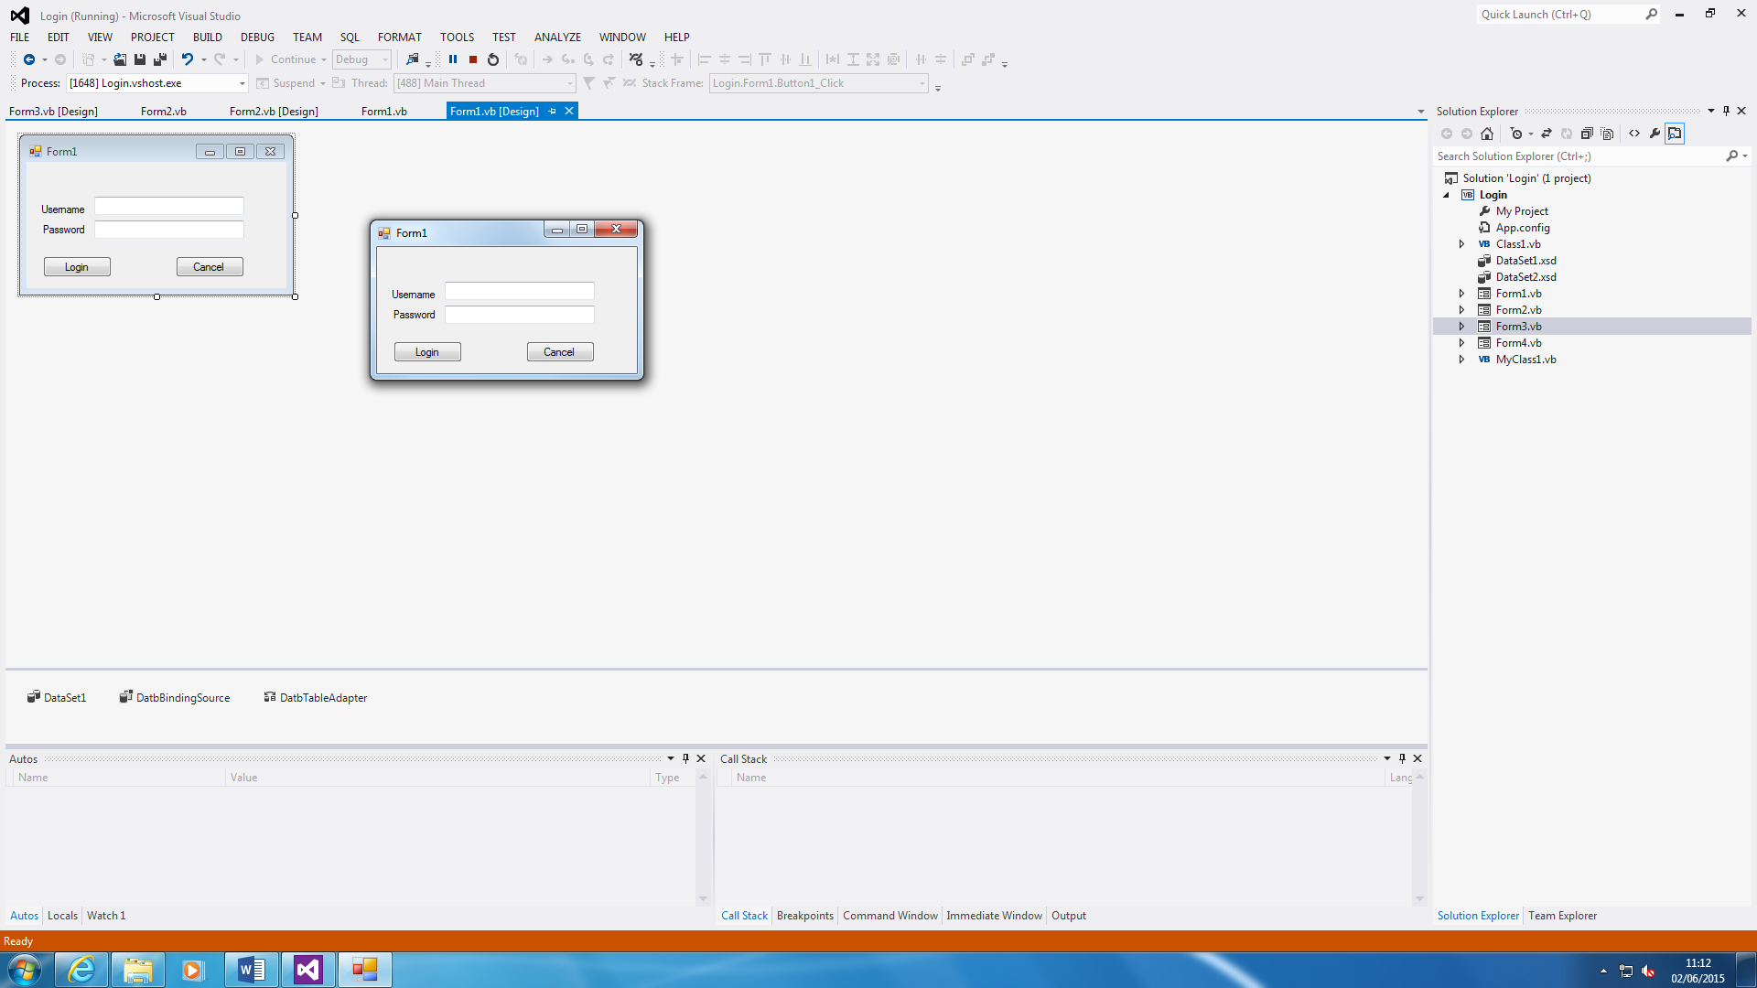

The username and password helps the user to log in to the application. This secures the application.

As you can see the codes below, it shows how the login works. The cancel button lets the user quit the application by pressing Cancel and removing all content that has been typed within the two boxes.

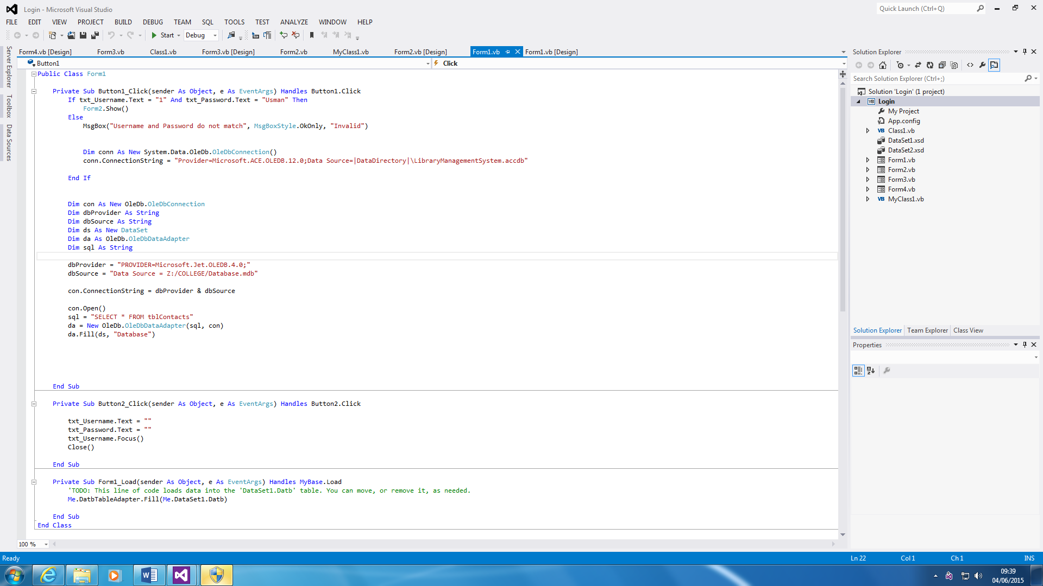

**Database**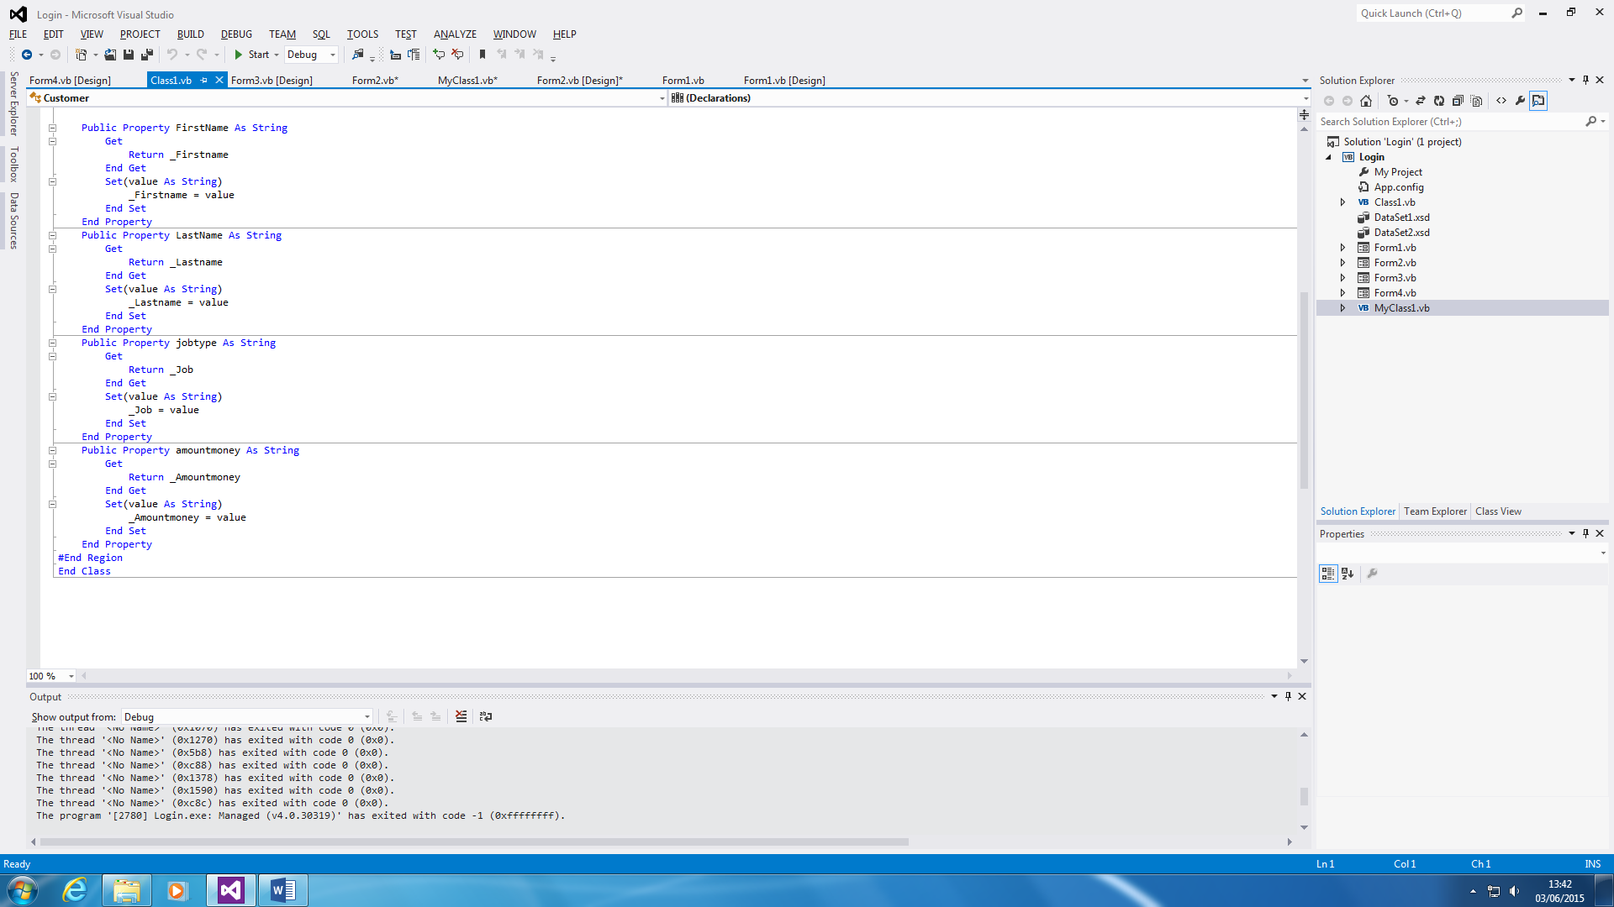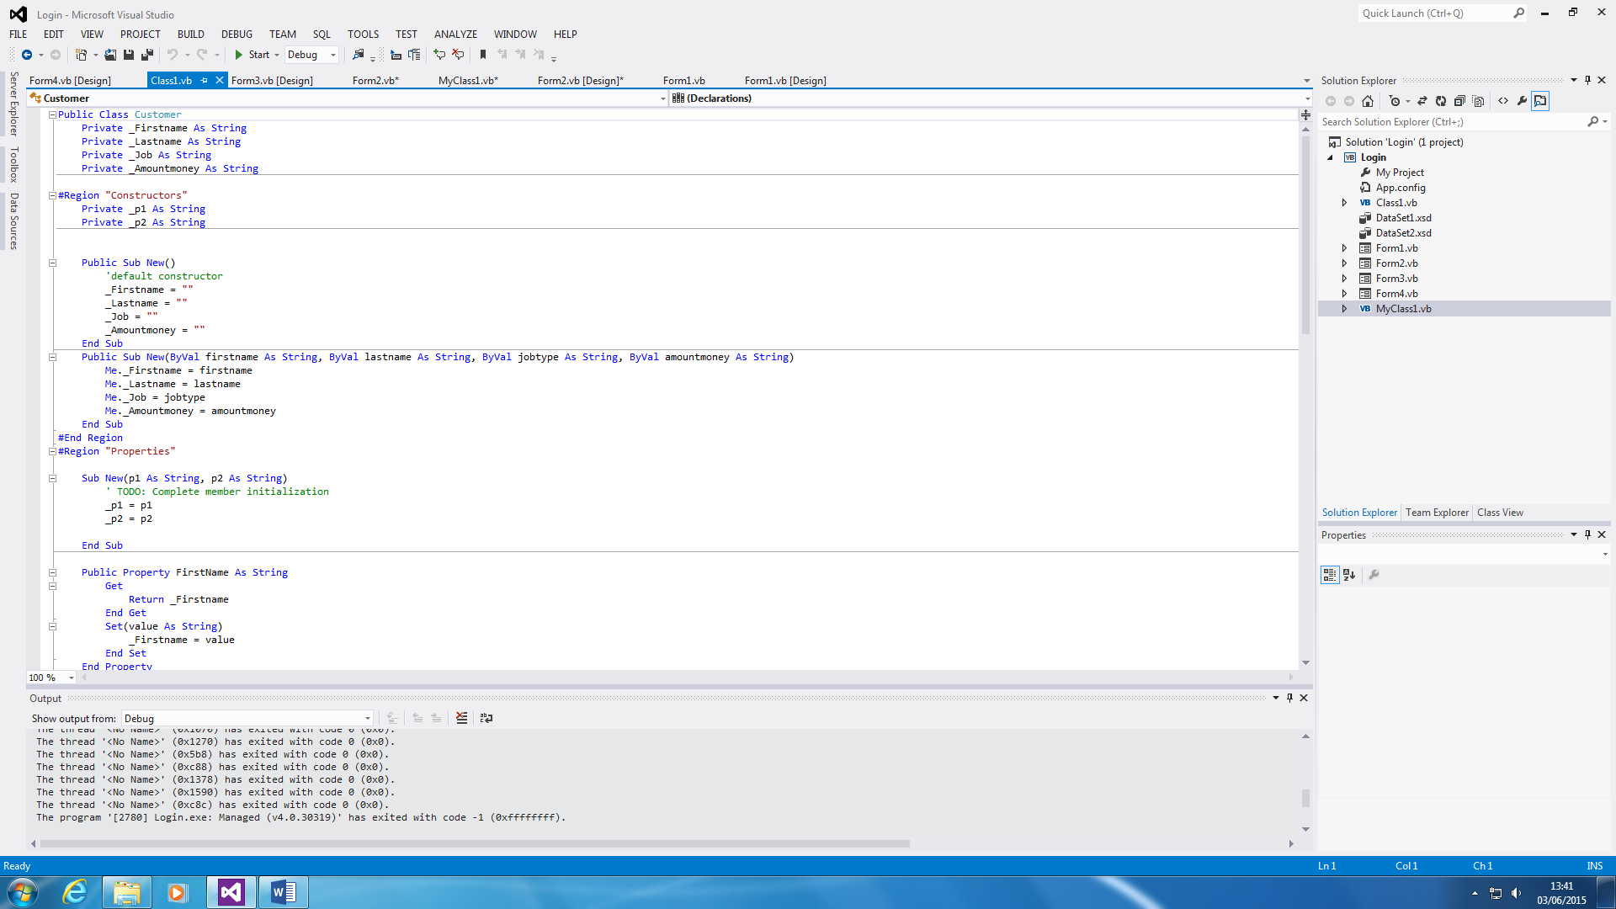

This is the Class code for the Database. This is all separated to construct the code for the Database code. The first section of the code uses it to tell what is what. It organises it. The second part tells is what to do. This is linked with Form3 too.

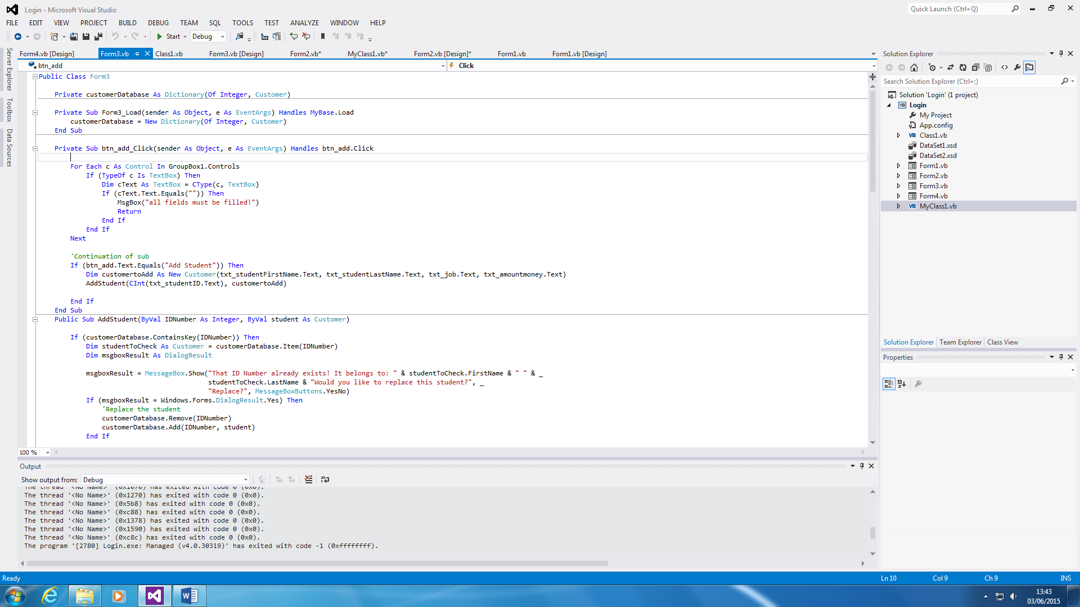

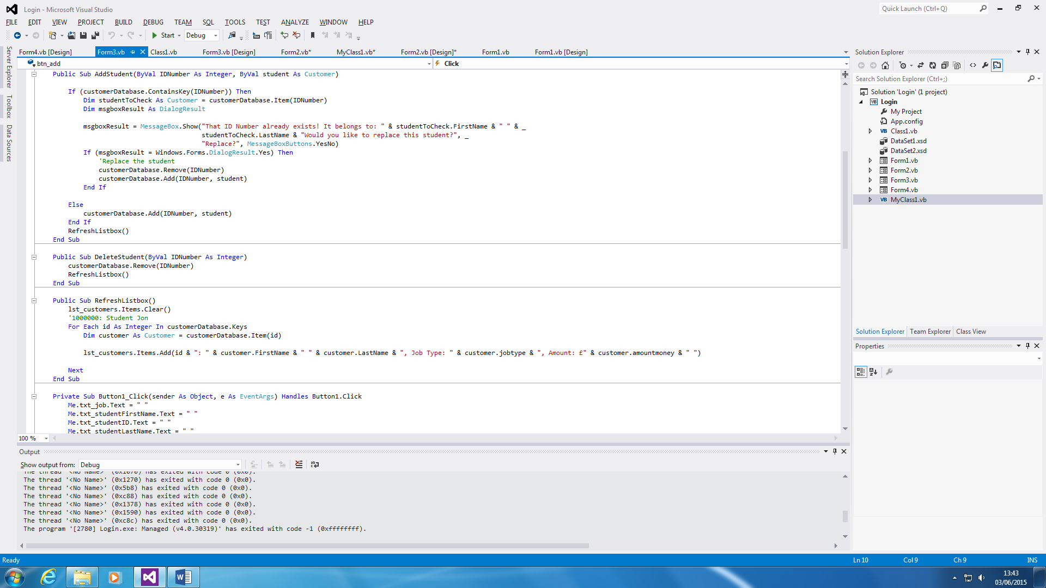

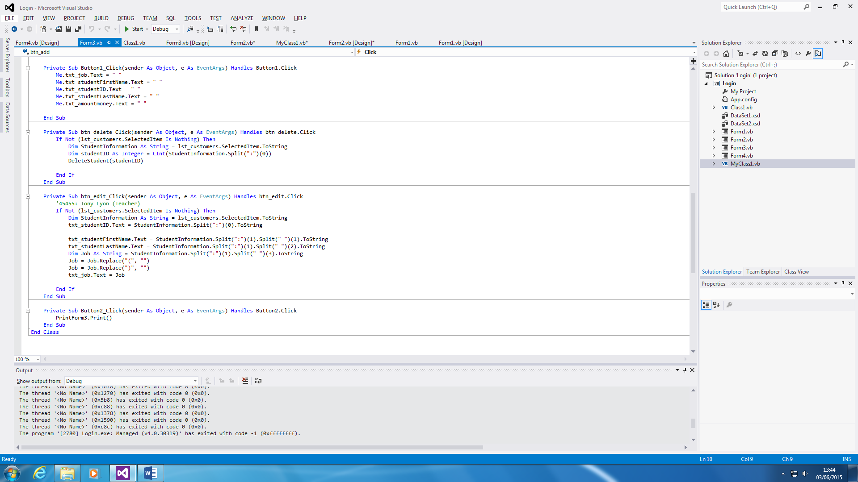

The first IF statement is the adding the customer. The second is removing a customer. The third is for the List Box and forth is clearing the whole section. They all do what it is set out to do. For example, the first section is to add the customer.

**Printing**

The printing part of the database is to print the summary. This is useful because once the user is complete with the database, the user can print it out to refer to.

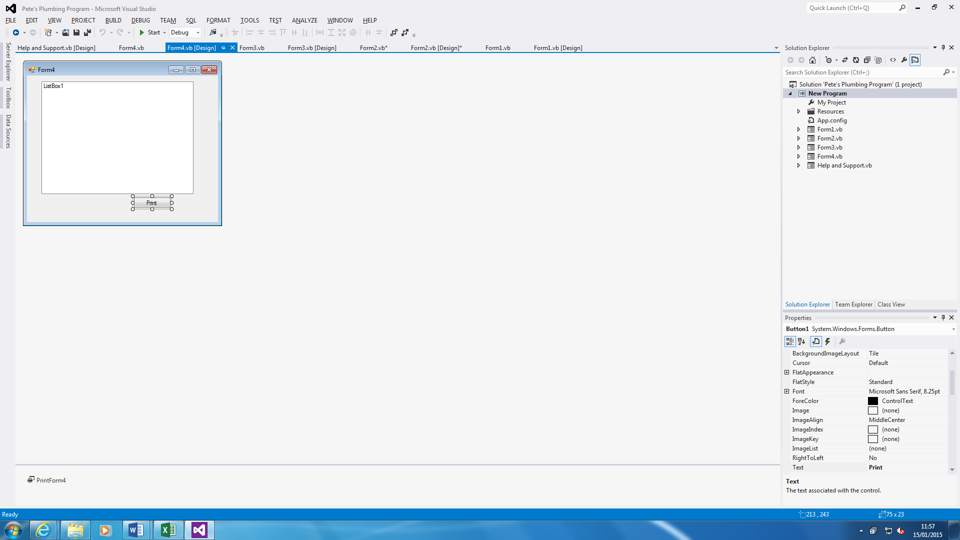

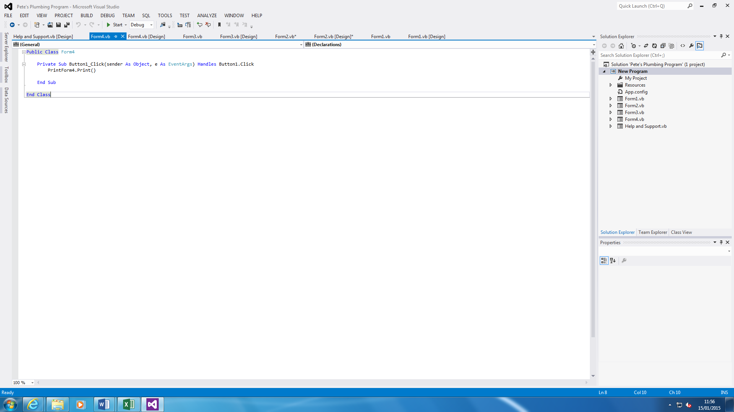

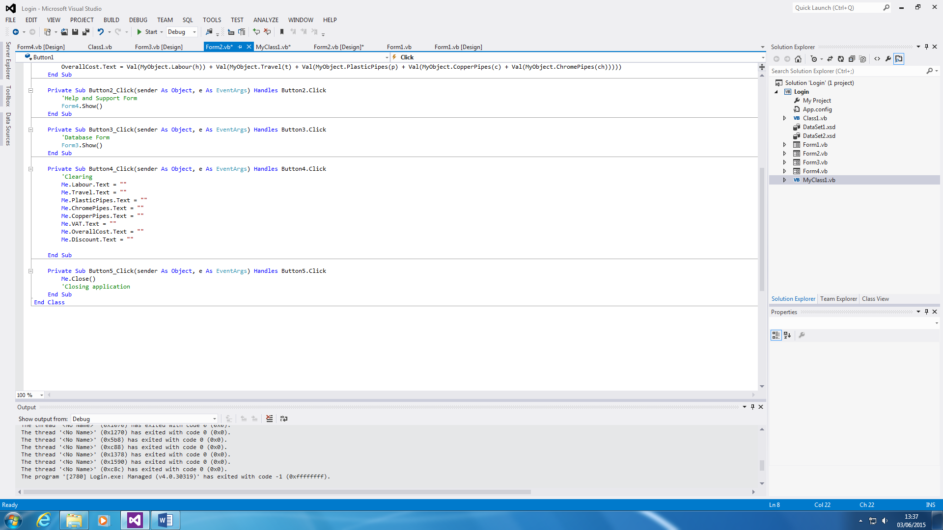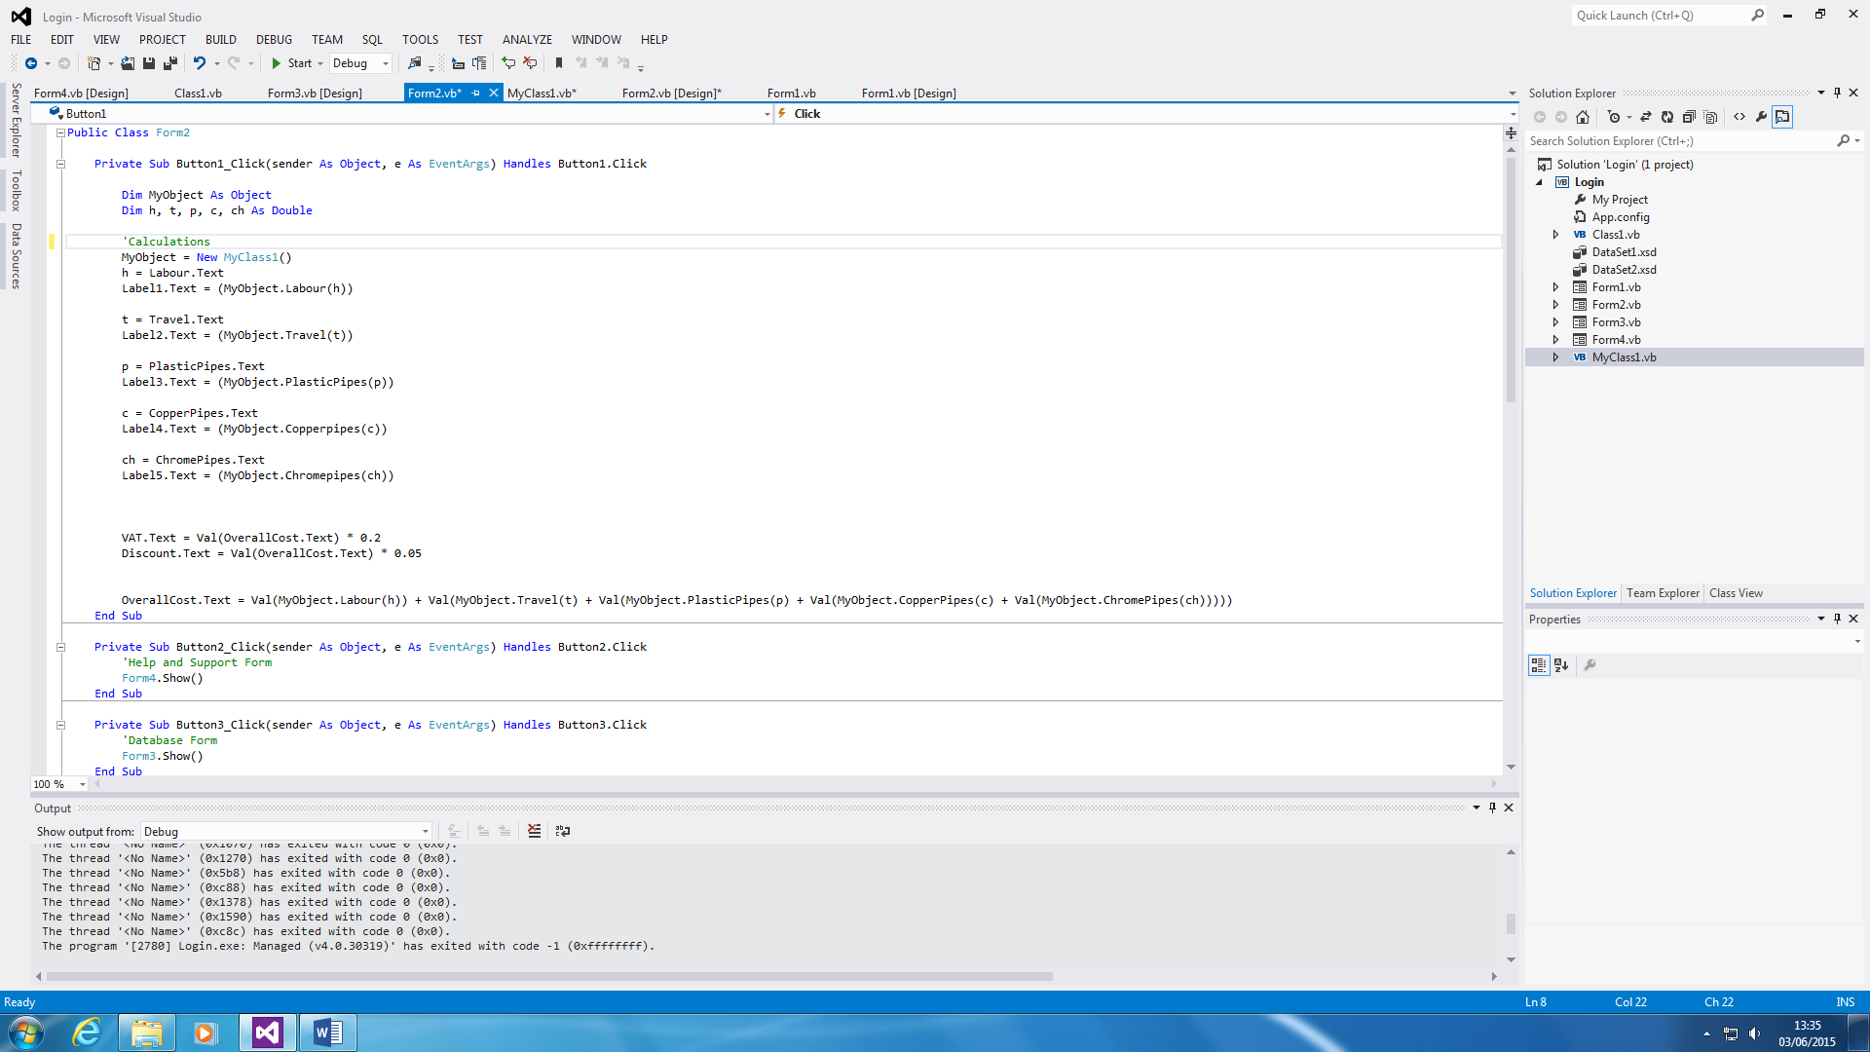**Main Form CODE**

This is the Main Form that only shows the Form2 codes. The Button1 is the calculation part that is linked to the Class Form, which the code is shown below. The code, “MyObject = New MyClass1 ()” links the Class and Form2 codes together. Button2 and Button3 is linked to the other forms.

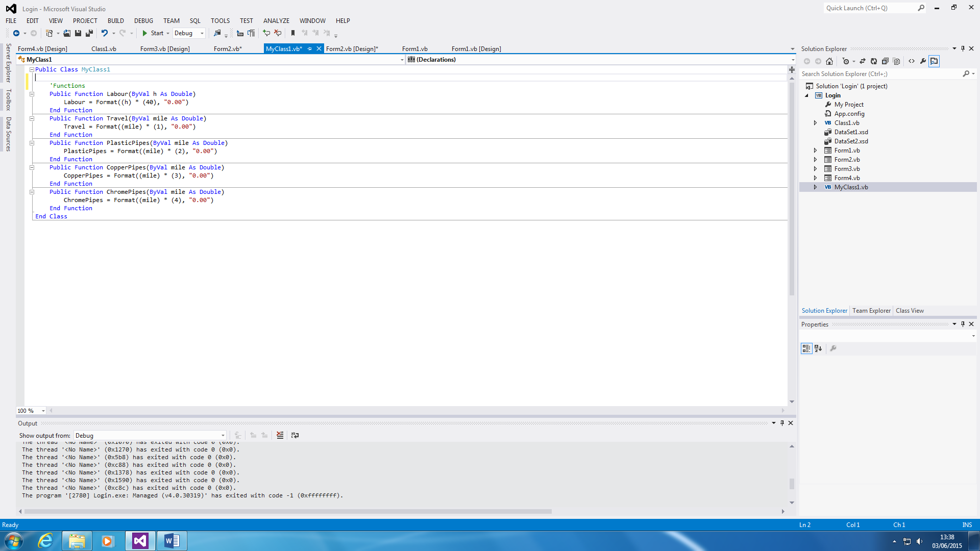

**Help and Support**

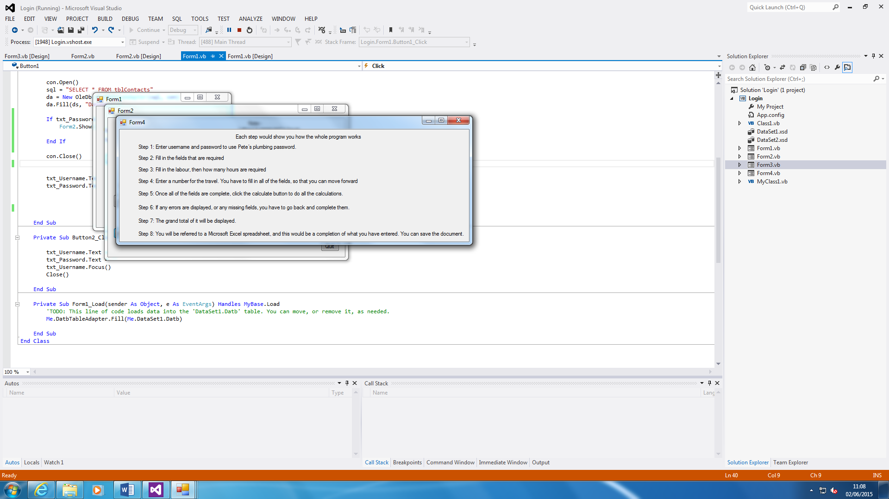

Help and Support button is easy. If the user has any problems with it, he/she can use the systematic guide of how the program is run. As you can see, it shows how it works. For example, if I did not know how to clear the whole Textboxes, I will use the Help and Support button to help me out. All you do is press the button and another sheet shows the steps.

For the user to get help for the program, all they need to do is go on to the main form and click on the button, ‘Help and Support’.

**Clearing**

This simply clears the calculations. If anything is wrong and the user wants to restart again, the user can simply clear the textboxes instead of restarting the whole program.